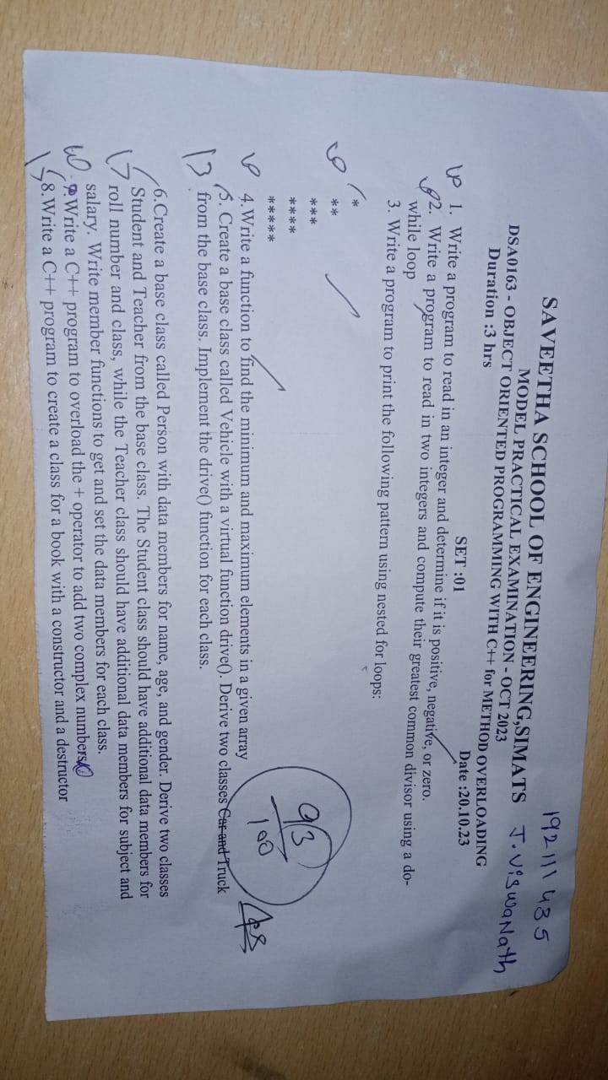

1.#include<iostream>

using namespace std;

int main(){

int n;

cout<<"enter the number: ";

cin>>n;

if(n<0){

cout<<n<<" is negative";

}

else if(n==0){

cout<<n<<" is Zero";

}

else{

cout<<n<<" is Positive";

}

}

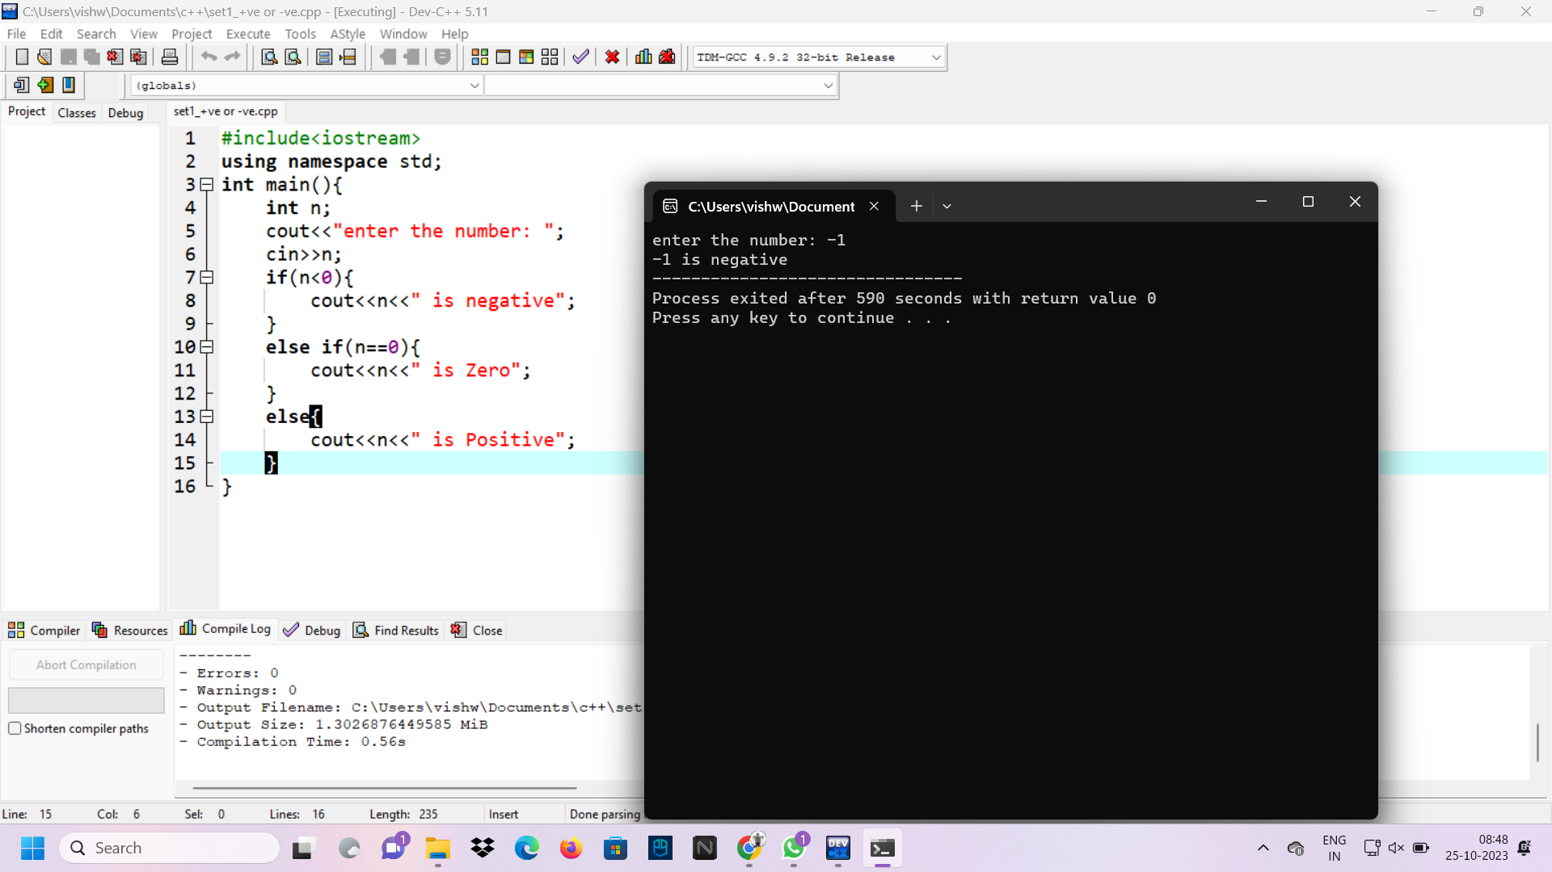

2.#include <iostream>

using namespace std;

int main() {

int n1, n2;

cout << "Enter two numbers: ";

cin >> n1 >> n2;

while(n1 != n2) {

if(n1 > n2)

n1 -= n2;

else

n2 -= n1;

}

cout << "gcd = " << n1;

return 0;

}

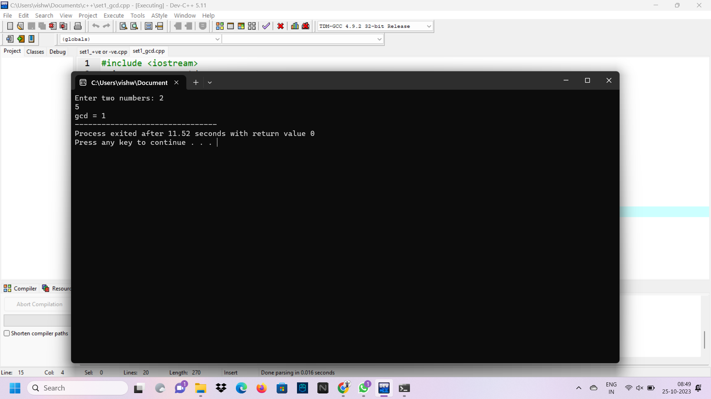

3.#include<iostream>

using namespace std;

int main(){

int a[100],i,n;

cout<<"enter the size fo array: ";

cin>>n;

cout<<"enter the array: ";

for(i=0;i<n;i++){

cin>>a[i];

}

int max = a[0], min = a[0];

for(int i = 1; i < n; i++){

if(max < a[i])

max = a[i];

if(min > a[i])

min = a[i];

}

cout<<"max= "<<max;

cout<<"min= "<<min;

}

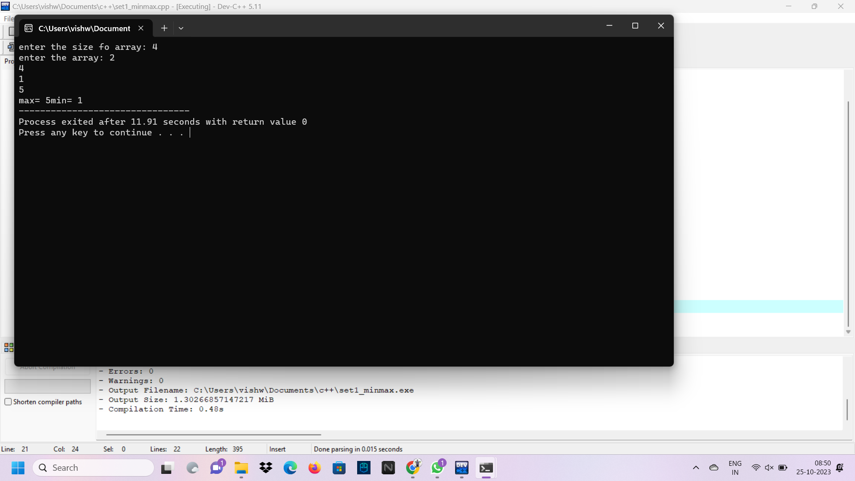

4.#include <iostream>

using namespace std;

void model(int n)

{

for (int i = 0; i < n; i++) {

for (int j = 0; j <= i; j++) {

cout << "*";

}

cout << endl;

}

}

int main()

{

int n ;

cout<<"enter the number of rows: ";

cin>>n;

model(n);

return 0;

}

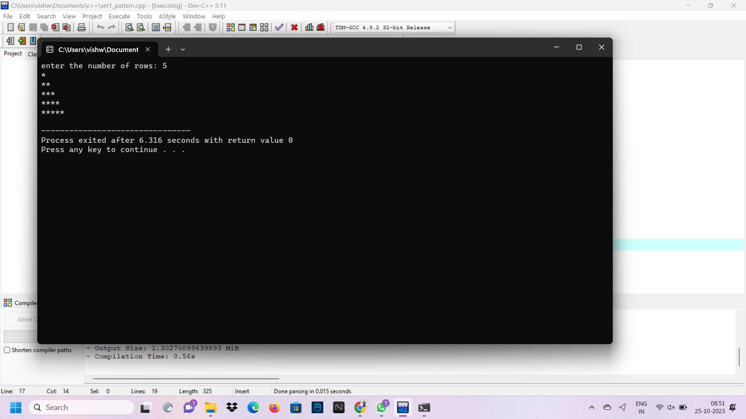

5.#include<iostream>

using namespace std;

class vehicle{

public:

virtual void drive(){

cout<<"Vehicle used to drive with load or passengers:"<<endl;

}

};

class car:public vehicle{

public:

void drive(){

cout<<"car will drive with passengers"<<endl;

}

};

class truck:public vehicle{

public:

void drive(){

cout<<"truck will drive with load"<<endl;

}

};

int main(){

vehicle *v,v1;

car c;

truck t;

v1.drive();

v=&c;

v->drive();

v1.drive();

v=&t;

v->drive();

}

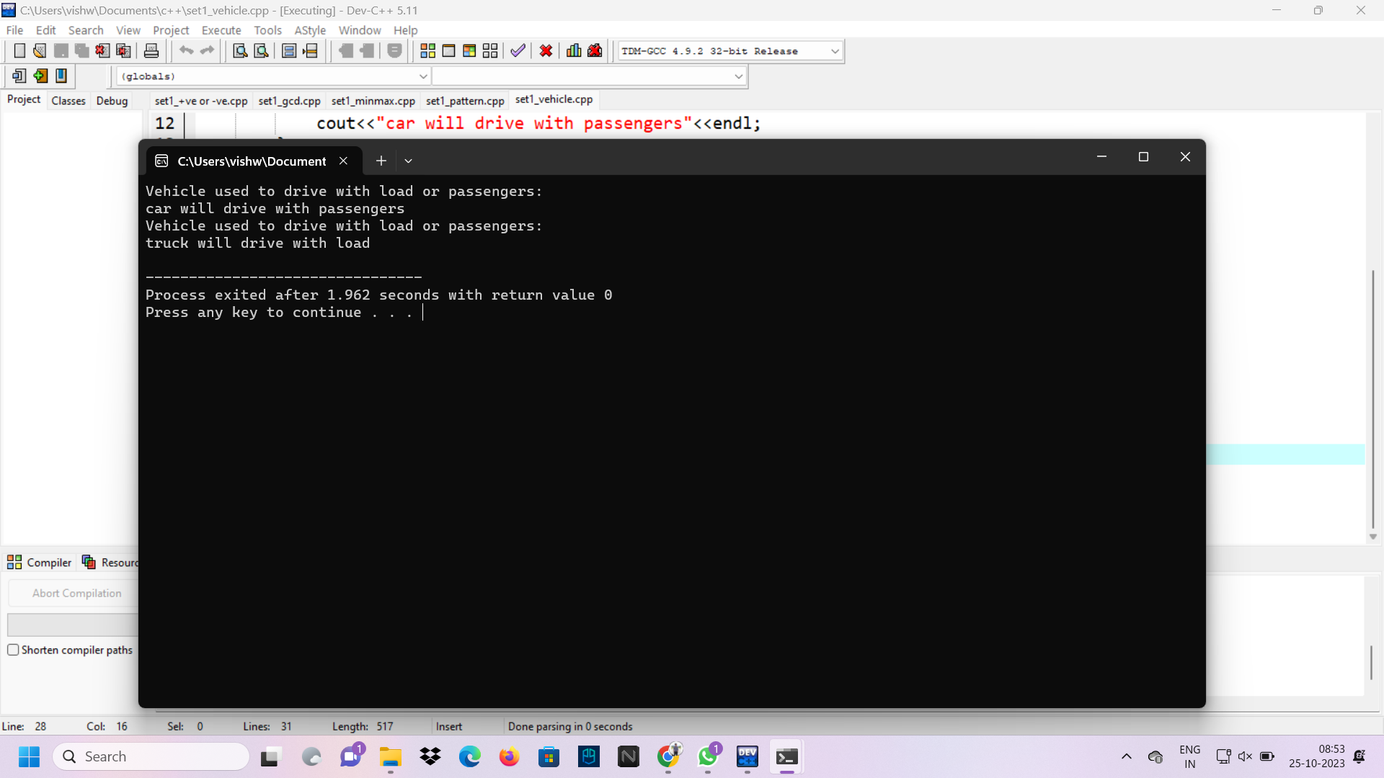

6.#include<iostream>

using namespace std;

class person{

public:

string name;

int age;

char gender;

void get1(){

cout<<"enter the name: ";

cin>>name;

cout<<"enter the age: ";

cin>>age;

cout<<"enter the gander: ";

cin>>gender;

}

};

class student: public person{

public:

int roll;

string class1;

void get2(){

cout<<"enter the roll number: ";

cin>>roll;

cout<<"enter the class: ";

cin>>class1;

}

void display(){

cout<<"NAME: "<<name<<endl;

cout<<"AGE: "<<age<<endl;

cout<<"GENDER: "<<gender<<endl;

cout<<"ROLL NUMBER: "<<roll<<endl;

cout<<"CLASS: "<<class1<<endl;

}

};

class teacher: public person{

public:

int salary;

string sub;

void get3(){

cout<<"enter the subject: ";

cin>>sub;

cout<<"enter the salary: ";

cin>>salary;

}

void display1(){

cout<<"NAME: "<<name<<endl;

cout<<"AGE: "<<age<<endl;

cout<<"GENDER: "<<gender<<endl;

cout<<"SUBJECT: "<<sub<<endl;

cout<<"SALARY: "<<salary<<endl;

}

};

int main(){

student s;

teacher t;

s.get1();

s.get2();

s.display();

t.get1();

t.get3();

t.display1();

}

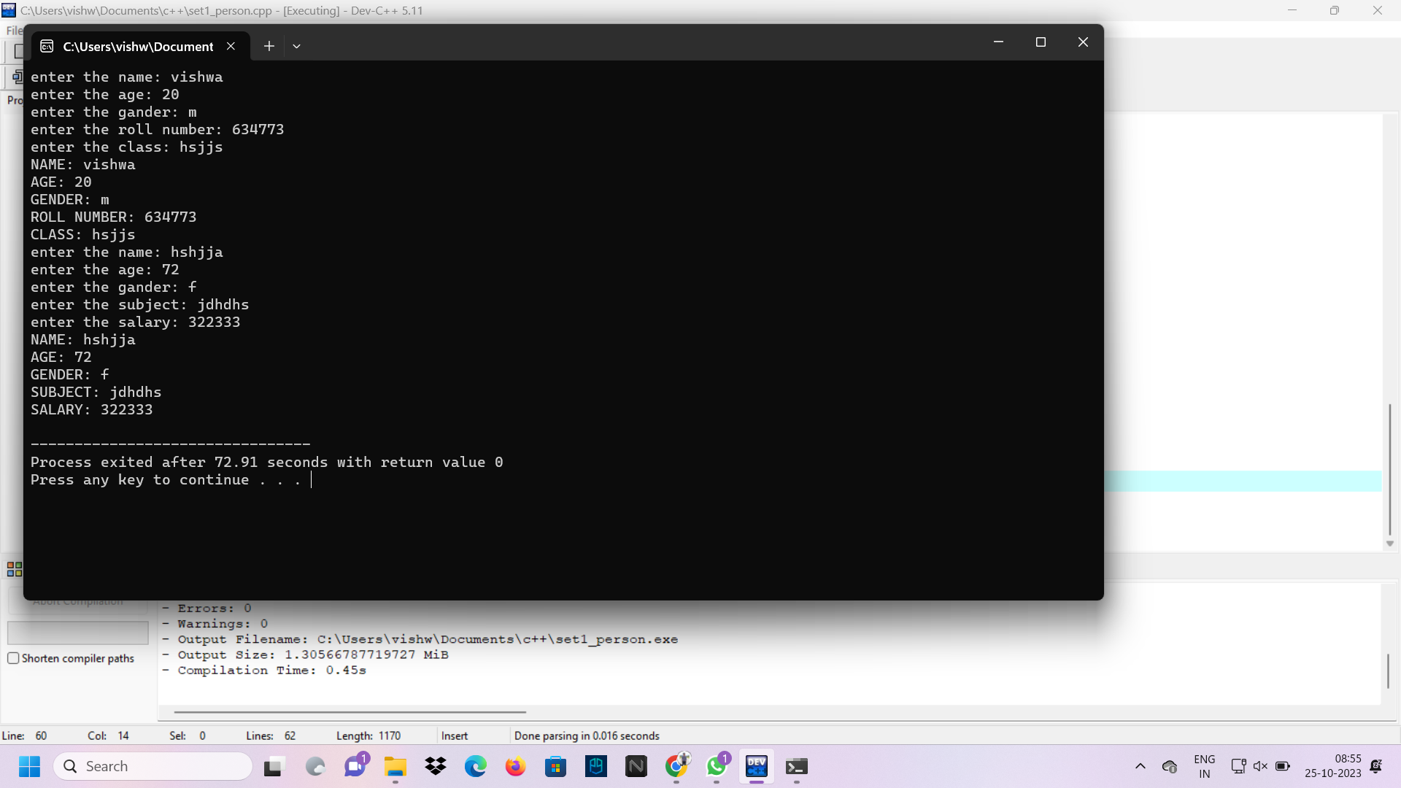

7.#include <iostream>

#include <sstream>

#include <cmath>

using namespace std;

class Complex {

public:

int real, imag;

Complex(){

real = imag = 0;

}

Complex (int r, int i){

real = r;

imag = i;

}

string to_string(){

stringstream ss;

if(imag >= 0)

ss << "(" << real << " + " << imag << "i)";

else

ss << "(" << real << " - " << abs(imag) << "i)";

return ss.str();

}

Complex operator+(Complex c2){

Complex ret;

ret.real = real + c2.real;

ret.imag = imag + c2.imag;

return ret;

}

};

int main(){

Complex c1(8,-5), c2(2,3);

Complex res = c1 + c2;

cout << res.to_string();

}

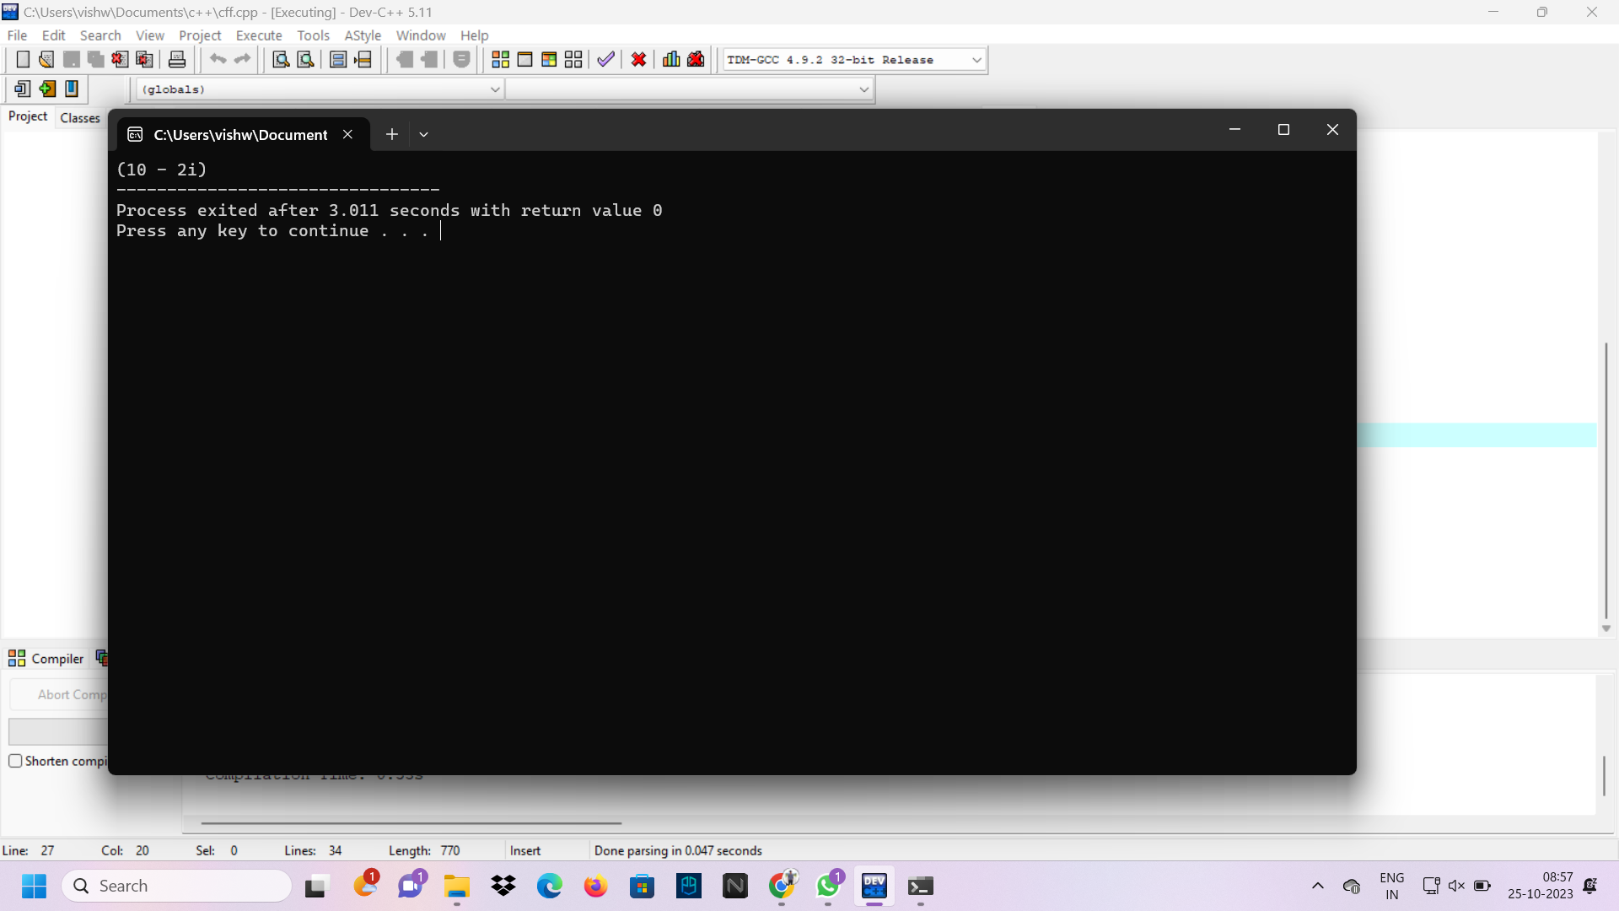

8.#include<iostream>

using namespace std;

class book{

public:

book(){

cout<<"i am book"<<endl;

}

~book(){

cout<<"Destructed";

}

};

int main(){

book b1;

}

